- Open a Word document.
- Display Mailings tab, put your cursor the right place where you want to insert the address block. Click Address Block button in Write & Insert Fields area.
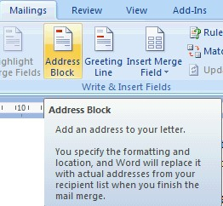
- The Insert Address Block dialog box appears.
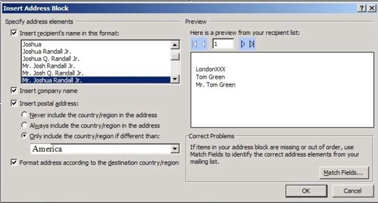
- You are allowed to specify the options or type for your address block in the dialog box.
♦ For example, choose a recipient name with the four triangle buttons, then In the Specify Address Elements area, if you mark the Insert Recipient's Name In This Format check box, you can choose the name format by clicking the type in the list box on the left.
♦ If your letter is prepare for a company, mark Insert Company Name box to add in the company's name in the address block.
♦ If you check the Insert Postal Address option box, you are asked whether and which type you need to include the country or region by selecting the three options.
♦ If the customers are related to some countries or regions that have specific address conventions which you had better respect and obey when you need to exchange with letters, then check the Format Address According To The Destination Country/Region option.
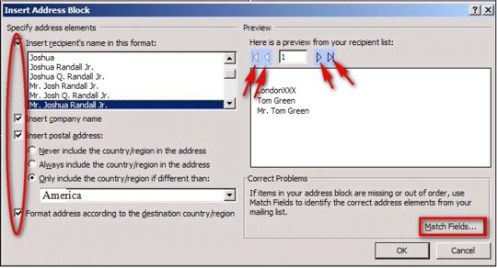
- Click Match Fields button to correct the order of elements in the address if the elements appear in the wrong order .
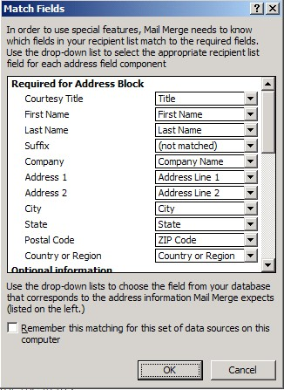
- ♦ Select the fields you want to match in each drop-down list under the Required For Address Block heading, select the field in each drop-down list.
♦ Mark the Remember This Matching For This Set Of Data Sources On This Computer check box if you need to set a same field matching later.
♦ Click OK to close the Match Fields dialog box.
- Click OK in the Insert Address Block dialog. You will see the address block has been inserted as an <<AddressBlock>> merge field.
